Georgetown Elementary Bus Stop Quick Reference
How to locate your child’s school bus stop, location, number, and time by using the Muscogee County School District’ s website. Please follow the pictorial pathway to Infofinderi. If you live within a 1.5 mile radius of Georgetown you are a designated walker.

Log on MCSD’s main page

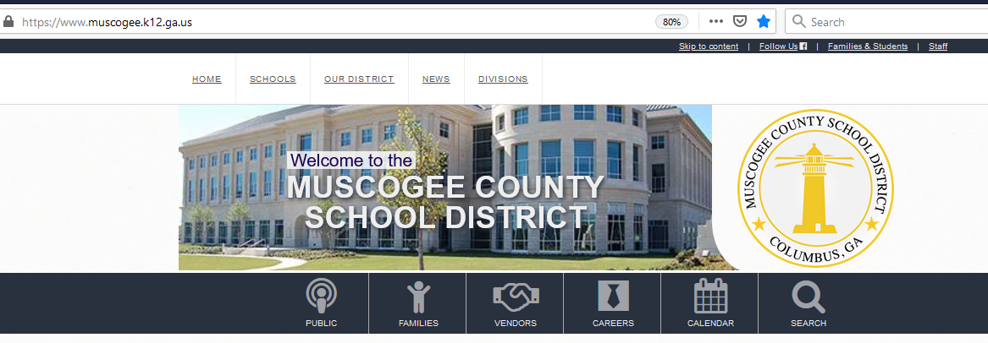

Click on the Families Icon

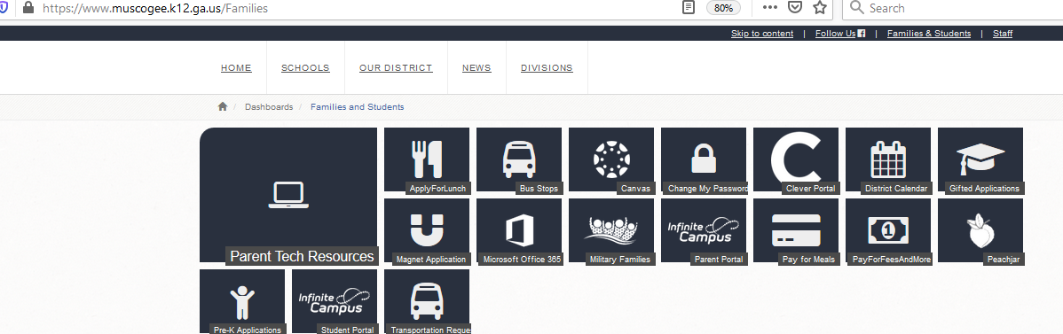
Click on Bus Stops Icon

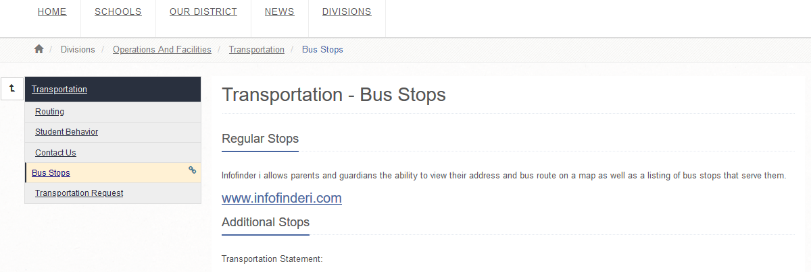

Click on www.infofinderi.com
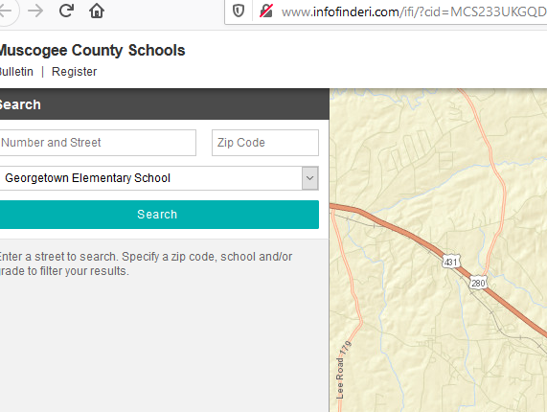
Type in number, street, and zip code

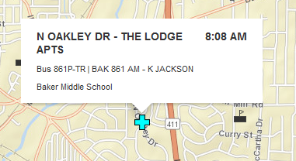
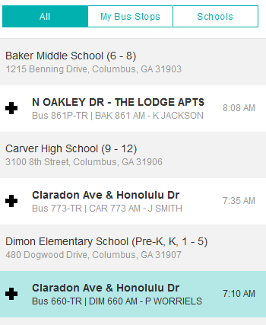
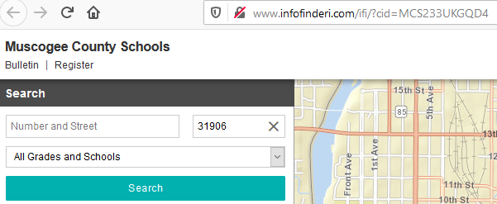
Click on your address. The bus number, time, and location of your bus stop will appear.
The school your child is zoned to attend will appear.

